**BUILD A EMPLOYEE TRAVEL APPROVAL APPLICATION FOR CORPORATES**

**1 Introduction**

**1.1 Over view :**

we already know that companies are organization mainly provide business travel business travel primarily aims to meet new people and crack deals to enhance business growth this is also beneficial for developing a relationship stakeholders .

* 1. **purpose:**

Most companies require the exact reasoning for that trip and a short justification the employee should justify why the journey is in the company interest and what benefits will come from it.

**2 problem and definition &design thinking**:

2.1 **empathy map:**

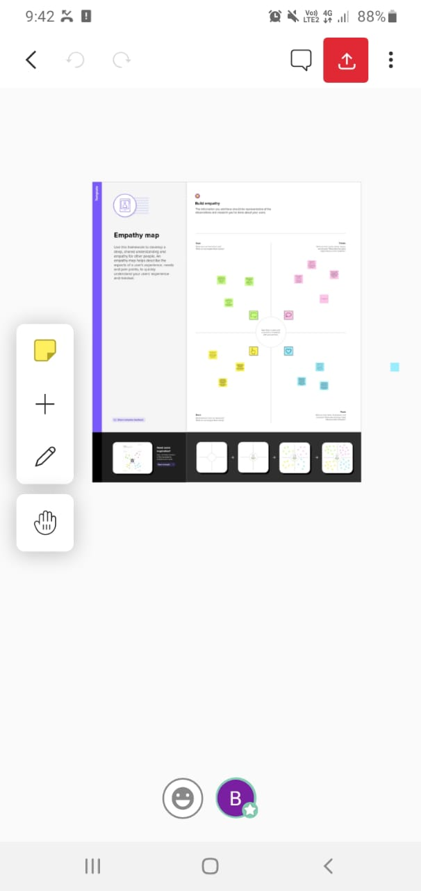

2.2 **ideation and brainstorming map**:

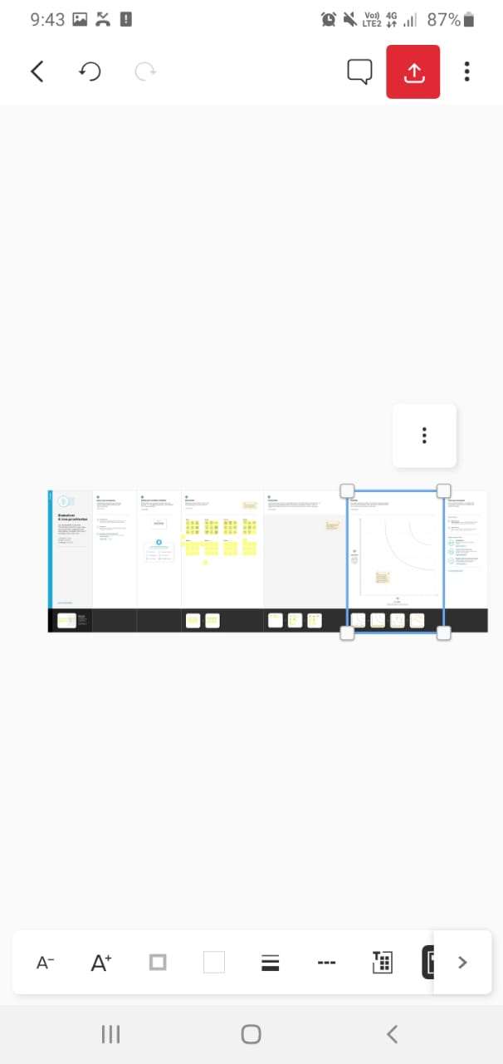

**3Result:**

**3.1** **DATA MODEL:**

|  |  |  |
| --- | --- | --- |
| Object name | Field in the object | |
|  | Field table | Data type |
| departments | report | Text |
| Students | report | text |
| Travel approval | report | text |

**3.2 activity &Screenshot**

**CREATING THE APPLICATION**

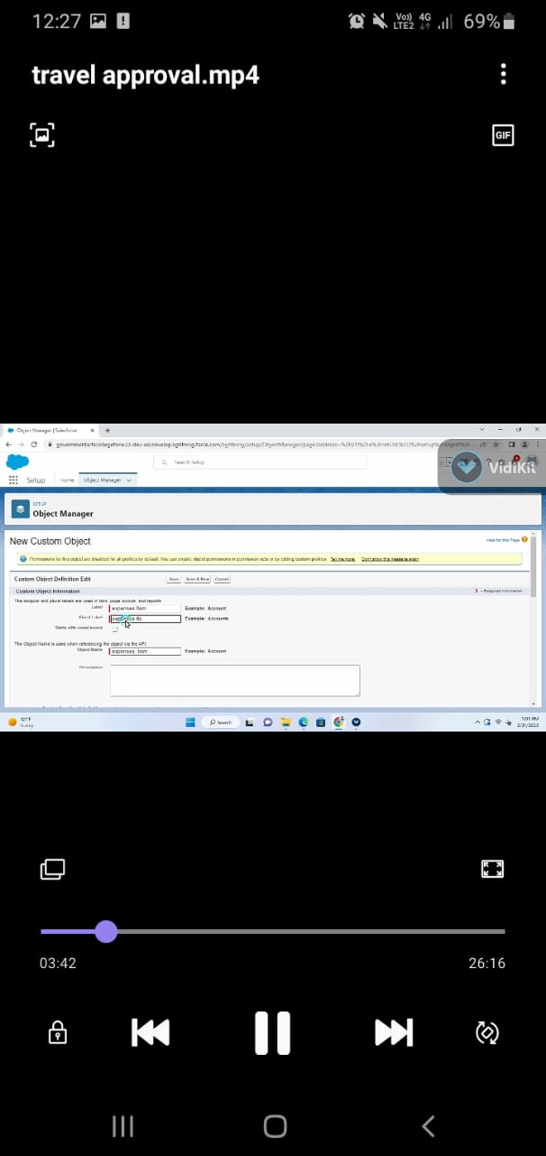

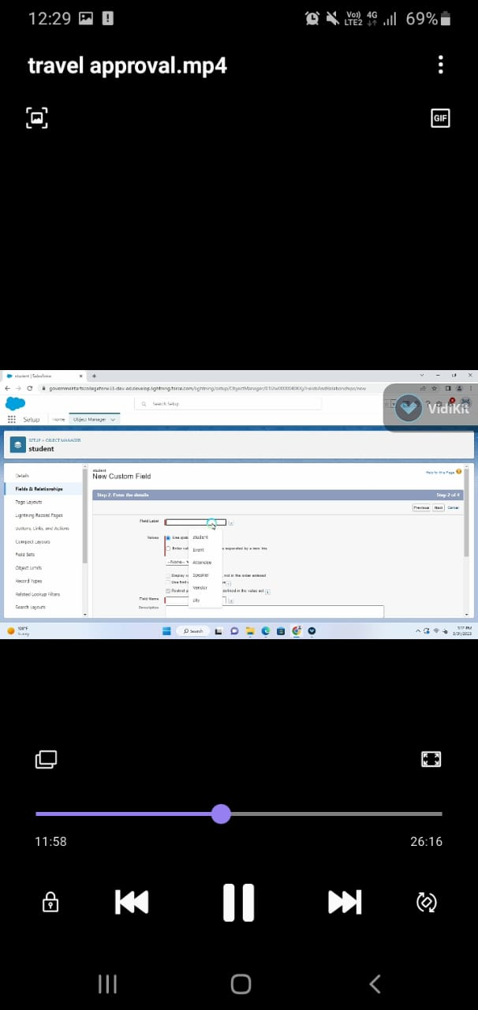**OBJECT:**

**TAB:**

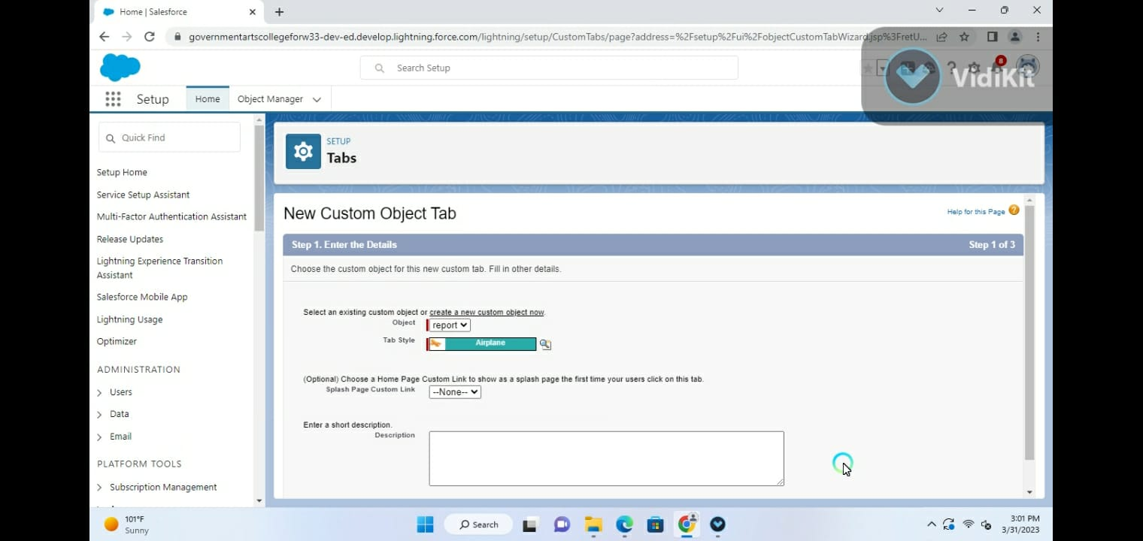

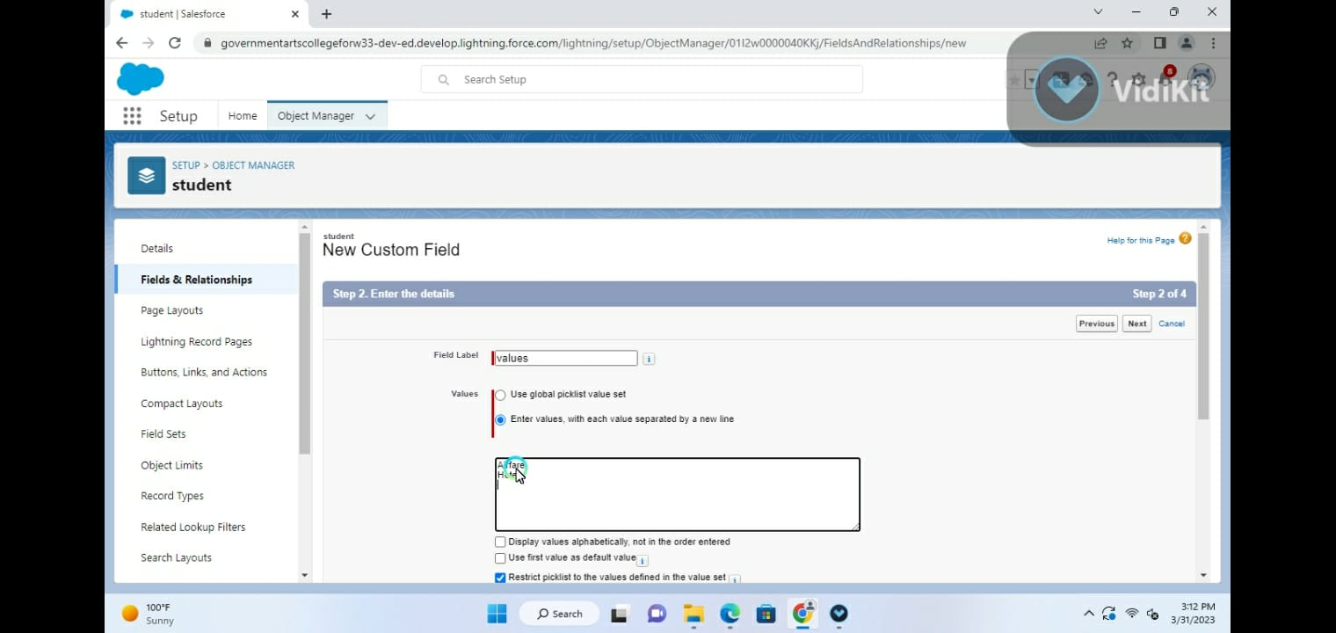**FIELD AND RELATIONSHIP**

**IMPORT DEPARTMENS**

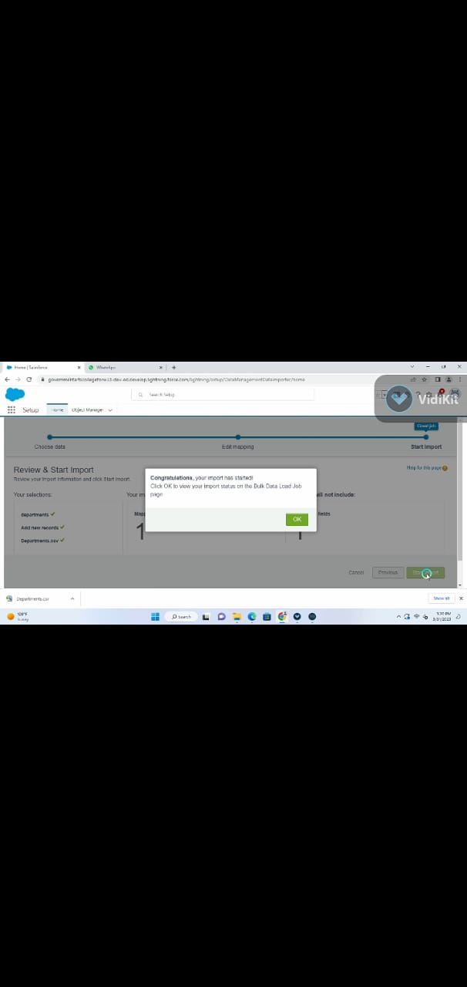

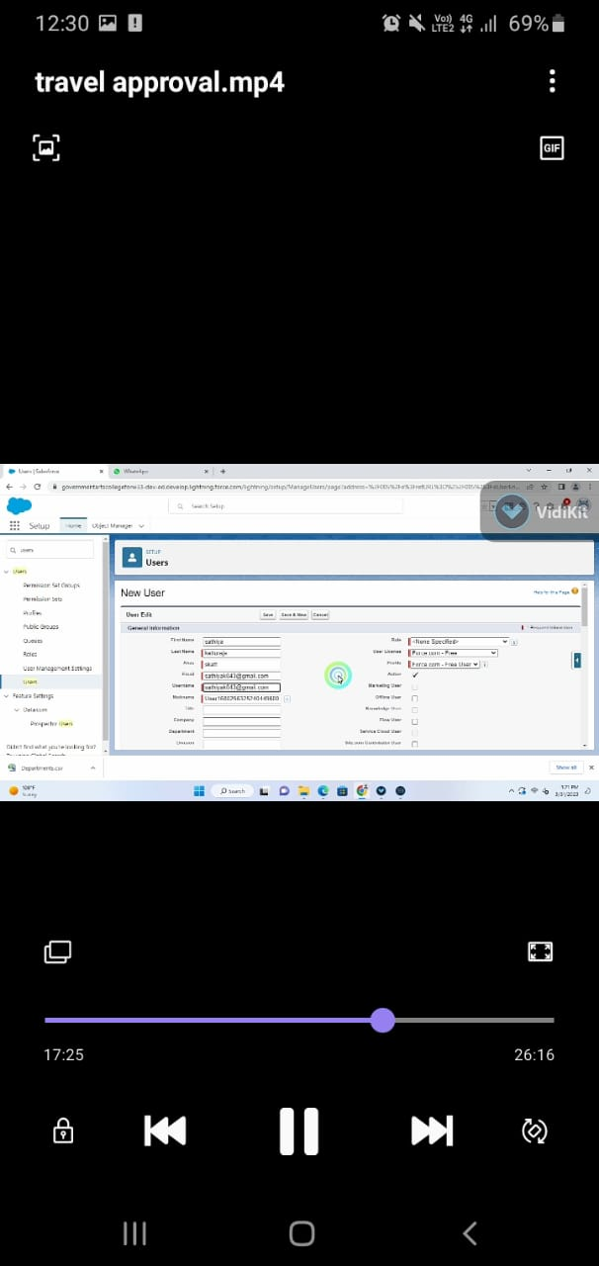**CUSTOMER USER INTERFACE**

**USE INFORMATION**

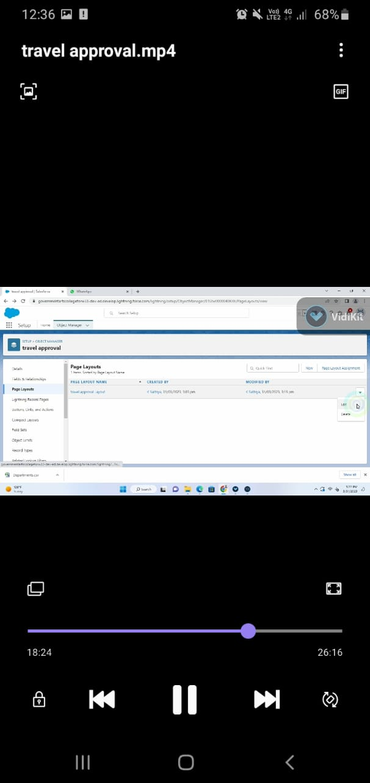

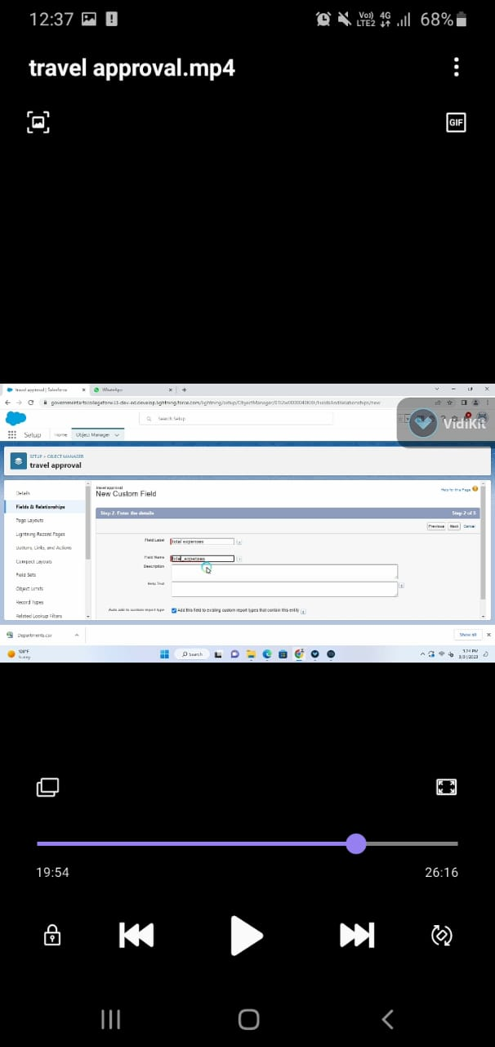**ADD BUSINESS LOGIC TO TRAVEL APP:**

**REPORTS:**

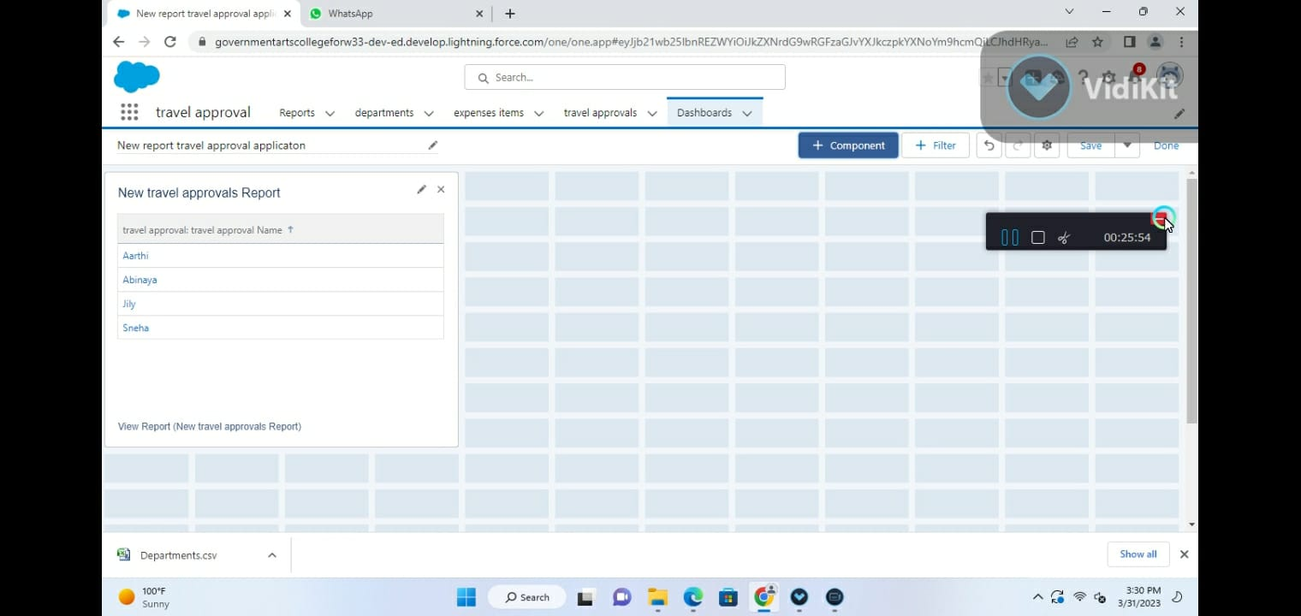

**4 Trailhead**

Team lead - https://trailblazer.me/id/bhavt12

Team member1 - https://trailblazer.me/id/muhim1

Team member2 - https://trailblazer.me/id/kkannan55

Team member3 - https://trailblazer.me/id/ashanmugam31

**5 Advantage:**

Meeting new people is a significant advantage of business travel because it helps to understand the business related perspective of the people Because of this people can also develop creativity in business organization .Apart from this, allows an understanding off the places culture .The face to face interaction will also improve to enhance the business network.

1 easy booking

2 cost savings

3 personalization

4 rewards

5 data security

**DISADVANTAGE:**

Business travel are expansive because companies spend a lot of money on it .Not only the plane ticket but companies also provided hotel costs, transportation costs and food services to their employees so it is evident that business travel is department on the tremendous amount of money of the organization sometimes it creates difficulty for the small startup business organization.

**6 APPLICATIONS:**

The travel support system is a sample application for natural ONE .as a sample application, its focus is to show Natural ONE functionally rather than being a full –fledged travel support application .

**7 conclusion**:

This blog concludes with the advantages and disadvantages of business travel. The primary purpose of business travel is to develop new ideas about business operation. On the other hand ,the disadvantage of business travel is that it enhances the organization expense .So it may affect the growth of the organization.

**8 FUTURE SCOPE:**

International travel is opening up quickly as countries lift travel restriction and Indians are starting to travel abroad in large numbers. This time, the growth in international travel is expected to be more spectacular than the pre-pandemic era. As per estimates, the Indian travel market will touch$125 billion mark by FY 27. With rapid building of airport infrastructures, and the reopening of global tourism, the Indian airline travel industry.